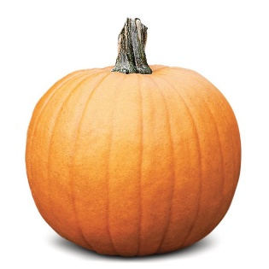
2018 Pumpkin Hunt – Entry Form
22 local businesses in Lerwick town centre have spooky pumpkins hiding in them – can you find them all to win an amazing prize?
Entry forms available online at www.livinglerwick.co.uk, or at the Lerwick Tourist Office.
Simply visit all the shops listed and mark down the number of the pumpkin – when you have finished, hand the completed form in to the Lerwick Tourist Office before 5.00pm on Wednesday 31st October and claim your free prize! Good Luck!
Open to all ages!
The Wine Shop |  | Ninian
Beggs Shoes |  | Parliamentary Office
Halcrows Menswear |  | R. W. Bayes
Envi |  | Westside Pine
George Robertsons |  | Camera Centre
Aurora |  | Smith & Robertsons
Harry’s Toy Department |  | Specsavers
High Level Music |  | Thulecraft
J. G. Rae |  | Universal Stores
Jamiesons Knitwear |  | Visit Scotland
Tangled |  | Love from Shetland

Name: ______________________________________________________

Address: ____________________________________________________
____________________________________________________

Contact Tel: _________________________________
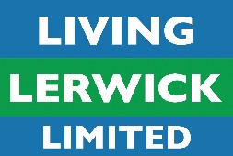
Date of Birth:_________________________________

