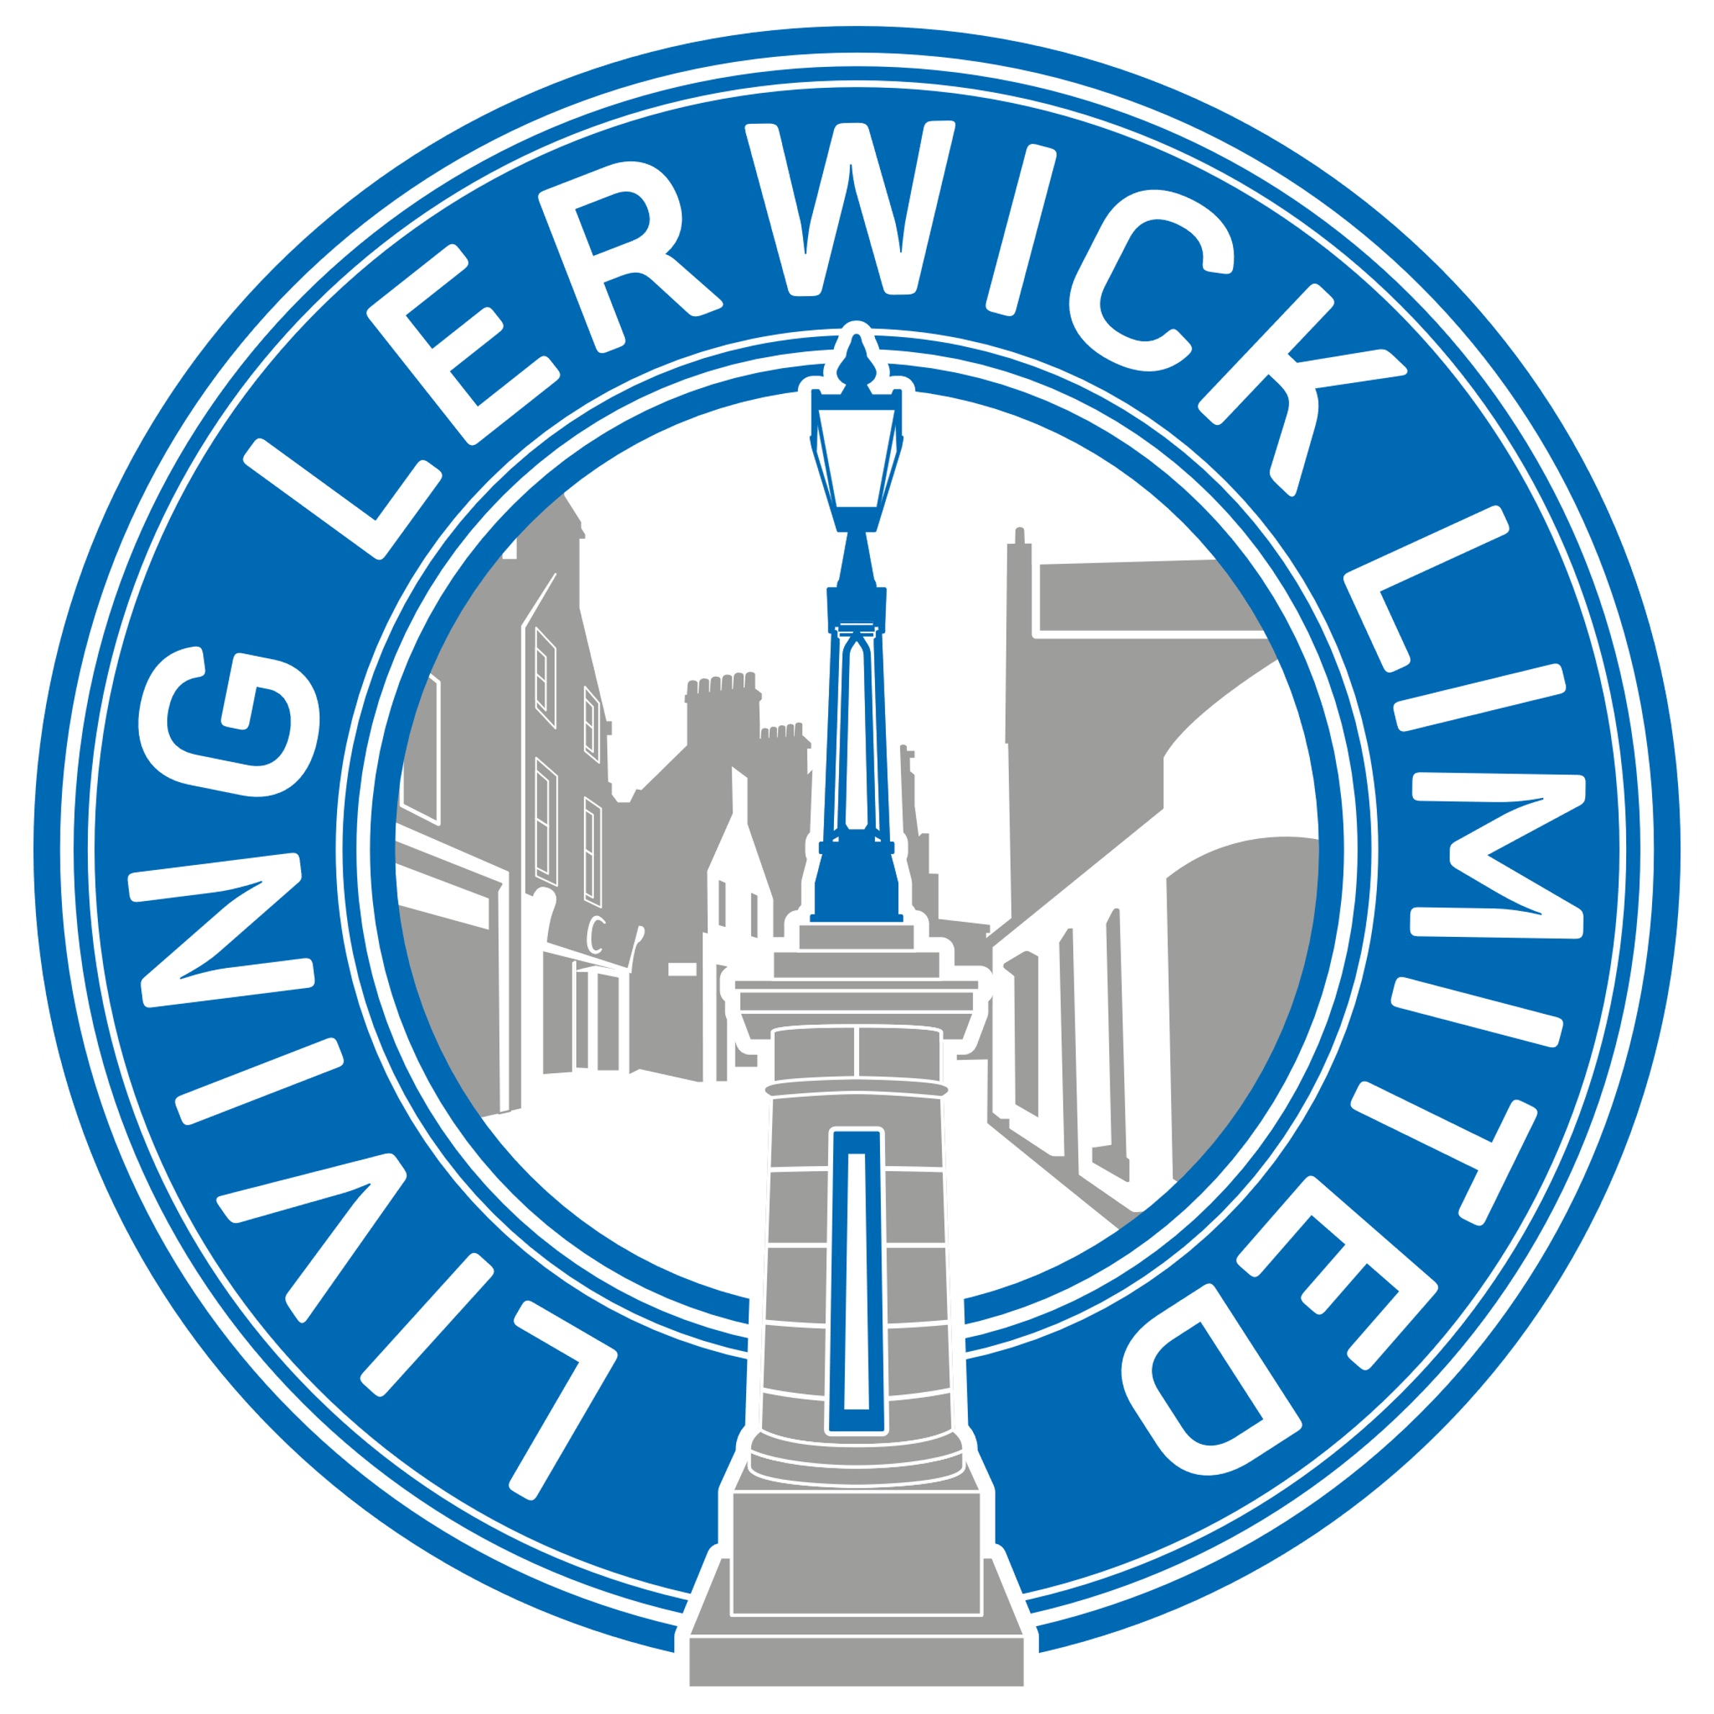
ELF HUNT
Find all the elves hiding in Commercial Street windows or they might even be hiding inside!!
Make a note of their name next to the business they are hiding in.
When you have located them all, return your completed sheet to the Tourist Information Office and collect your prize!
ANDERSON & CO
ANTIQUES & COLLECTABLES
AURORA
BEGGS
BURNS LANE CLOTHING
CAMERA CENTRE
GEORGE ROBERTSONS
INTERSPORT
JAMIESONS
LHD CUSTOM CLOTHING
LOVE FROM SHETLAND
LERWICK PORT AUTORITY
M&CO
NINIAN
NORDSTERNA BOUTIQUE
OUTDOOR TREK
PEERIE ISLES
PEERIE CAFÉ
R.A.M
RW BAYES
ROYAL BANK OF SCOTLAND
SPECSAVERS
TOURIST INFORMATION SHOP
THULECRAFT
WINE SHOP
WESTSIDE PINE
UNIVERSAL STORES
Hand your form into the VisitScotland office by 5pm on Monday 20th December to collect your reward.

